Turnitin Rubric Quickstart Guide

Summer 2013

Table of Contents

Create a Rubric 3
Insert a Rubric into an Assignment 3
Rubric Manager Basics 3
Add a Column for a Scoring Scale 4
Add a Row for a Criterion 5
Delete a Rubric or Column 5
Edit a Rubric 5
Use Rubric to Generate Grades 5
Manage Rubrics 5
Edit a Rubric 5
Duplicate a Rubric 6
Export/Import 6

Create a Rubric

Insert a Rubric into an Assignment
- Log in to http://turnitin.psu.edu.
- If necessary, click the Add a Class button to create a class.
- Within your class, click the Add Assignment button.
- Click Optional Settings to reveal additional assignment choices, including grammar checking and rubric settings.
- To attach a rubric in Grademark, click the Launch Rubric Manager. A rubric window will be displayed.
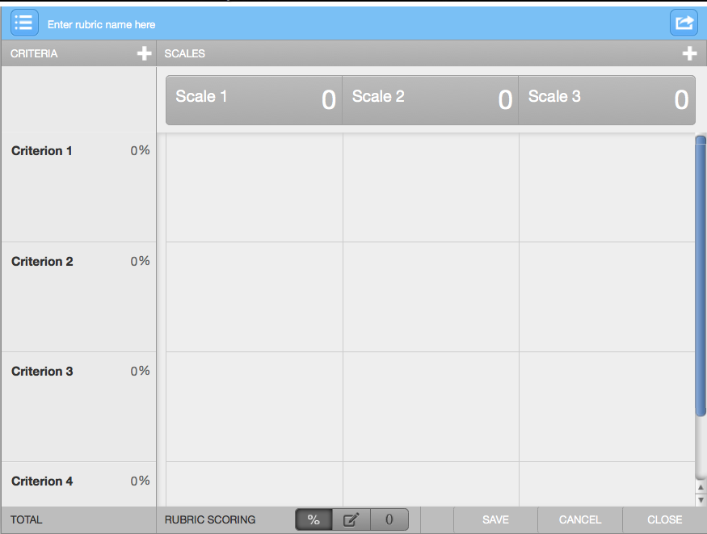

Rubric Manager Basics
- In the rubric manager, click the rubric options button (list icon) in the upper left and select the “Create a rubric option” in the drop down menu.
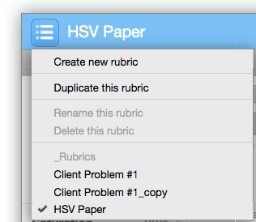
- Add a rubric title at the top of the rubric. The example below is titled “Essay 1 Rubric”
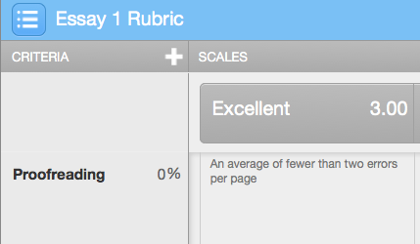
Rubric title area.
- For each scale in the top row, enter a text description (e.g. “Excellent”, “Average”) and then a point value for that scale (e.g. 1.00, 2.00).
- For each Criterion in the left column, describe the item that is being scored in that row (e.g. “Grammar”, “Bibliography”).
- Assign a percentage of the total score in each Criterion.
Note: Rubric scoring set to “Percentage” by default, but can be switched to “Points” or “Qualitative” (no numeric score) at the bottom.
- In each cell of a Criterion row, describe the standard that must be met in order to achieve that score.
- Click Save as needed to save changes. Click Save

Add a Column for a Scoring Scale
Click the plus button at the far right of the Scales area to add a new column for a scoring scale.

Add a Row for a Criterion
Click the plus button in the top of the Criteria column to add a new row for a Criterion.

Delete a Rubric or Column
- Move your cursor to either a Criterion cell in the far left or a Scale cell in the top.
- A trash can icon will appear. Click the icon to delete the row or column.

Edit a Rubric
See the “Manage Rubrics” section for instructions.
Note: Once a rubric is used to grade an assignment, it can no longer be edited. It can be duplicated or exported/re-imported.

Use Rubric to Generate Grades
- Log in to http://turnitin.psu.edu.
- Navigate to your list of assignments.
- Click View in the row of the appropriate assignment.
- Click the link for each paper title to open the Document Viewer.
- Click the Grademark button in the upper left to open the Grademark options.
- At the bottom right, click the rubric (grid) icon to display the rubric.
Click grid icon (next to last) to open the rubric.
- For each Criterion row, click the score you feel the paper earned. Scores will be totaled for a final grade.
- Click Apply rubric percentage to grade (or points) to calculate an assignment score.

Manage Rubrics

Edit a Rubric
Note: Once a rubric is used to grade an assignment, it can no longer be edited. It can be deleted or exported/re-imported.

- Navigate to your list of assignments.
- Click the More Actions link in the row for the appropriate assignment.
- Click the link for Edit Settings in pop-up menu.
- Click Optional settings to reveal the Grademark option.
- Verify that the correct rubric has been attached to your assignment.
- Click Launch Rubric Manager to open the editor. Select the rubric associated with the assignment.
- Edit the rubric as needed, then click Close to save changes.
- Click Submit to exit the assignment editor.

Duplicate a Rubric
Duplicating a rubric is one way to re-use the same rubric in multiple assignments.

- Open the Rubric Manager following the instructions listed in the previous section.
- In the rubric manager, click the rubric options button (list icon) in the upper left and open an appropriate rubric.
- Click the rubric options again and select Duplicate this Rubric.
- Rename the copy and edit as needed.
- Attach this rubric to a new assignment when the assignment is created or edited.

Export/Import
One way to share rubrics between instructors is to export the rubric as a file and then give that file to a second instructor to import.

Export a Rubric
- Open the appropriate rubric to export.
- Click the import/export button at the upper right (box with arrow icon).
Import/Export at upper right.
- Select the Export option.
- Save the file to a location you can easily access.
Note: This file can be shared with another instructor.

Import a Rubric
- Open the appropriate rubric to export.
- Click the import/export button at the upper right (box with arrow icon).
Import/Export at upper right.
- Select the Import option.
- Click the Browse button and find the appropriate rubric file.
- Click the Import button to import the file into your rubric manager.
- Click Close to view the rubric.

