ANGEL Turnitin Student Quickstart

Upload Document
Note: The recommended browser for uploading documents is currently Firefox.

- Log in to ANGEL at http://cms.psu.edu and access your course.
Note: Uploading assignments into Turnitin outside of ANGEL could affect how your grade is recorded.
- In the Lessons tab, click on a link that your instructor identifies as a Turnitin assignment. This will open the Turnitin assignment dashboard.
- Click the Information icon to view due dates and instructions.
- Click the Upload icon to begin an upload. Follow the instructions to complete the upload.
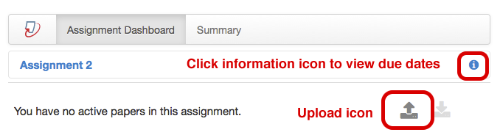

View Grades and Reports
Once a document is uploaded, it will appear in the assignment dashboard. You will be able to see
- A grade once it is recorded
- Percentage reported from any Originality Reports your instructor allows you to access
- Download icon
Uploaded paper with a grade of 35 and the download icon activated. No Originality Report was generated.

PeerMark
An instructor may assign a PeerMark peer review assignment in which students critique other students’ assignments. If that is the case, do the following.

- Open the Turnitin assignment from within ANGEL.
- Click the tab for PeerMark Reviews.
- In the PeerReview window, click the Write Reviews tab to begin your review.
- Reviews of your assignment will be visible in this window after they are written by your classmates.

